AIR UNIVERSITY  ISLAMABAD CAMPUS • ACADEMIC SUBMISSION | AU

ACADEMIC ASSIGNMENT
Lab Task 1:
NO. 01
Full Stack Web Development
Lab 2 Task
SUBMISSION DETAILS
COURSE CODE | [CS – 000]
SUBMITTED TO | Miss Fizza
SUBMITTED BY | Muhammad Zakria
REGISTRATION NO. | 241856
PROGRAM | BS Computer Science
SEMESTER / SECTION | 5th Semester • Section [C]
SUBMISSION DATE | 9/18/2026
PREPARED FOR ACADEMIC SUBMISSION
Air University • Islamabad, Pakistan | BSCS • SEM 05

Main Tasks:
For full codes visit git hub:
Dashboard:
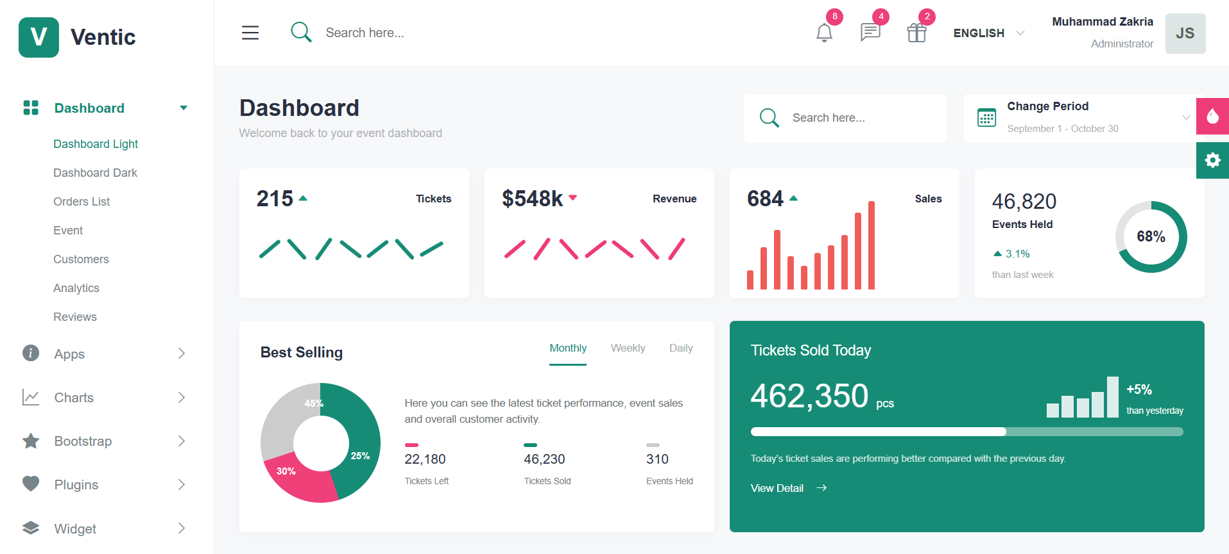

Task 1-6:
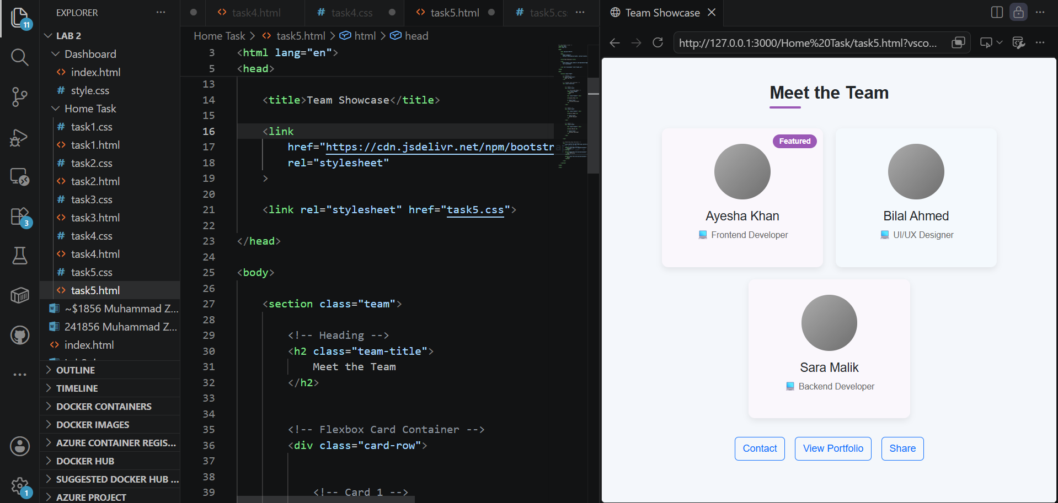

Final Output:
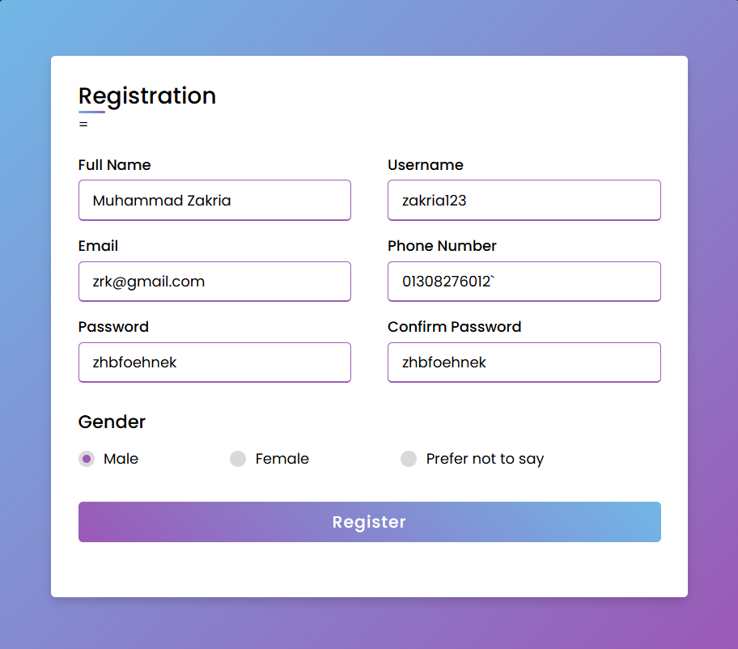
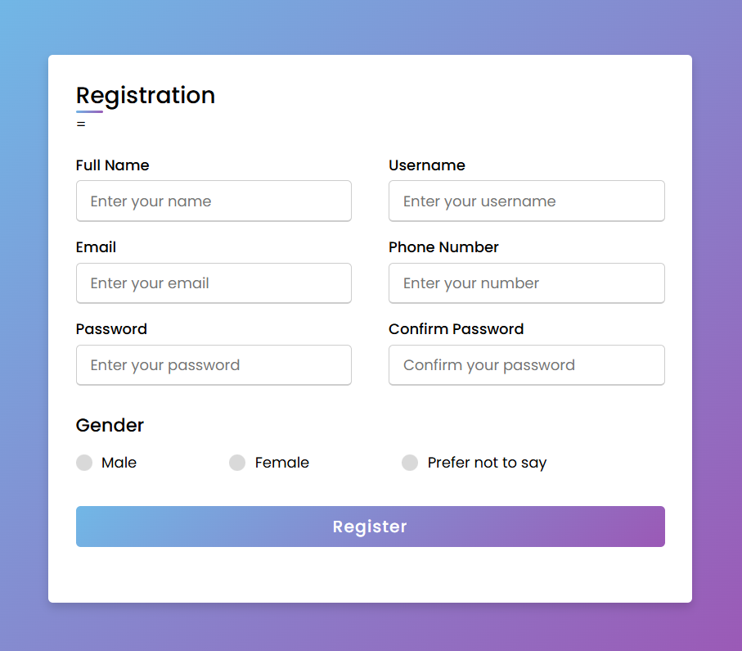

Html:
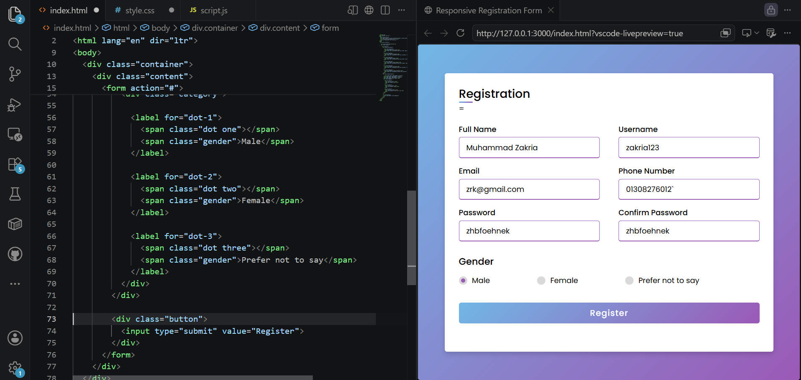
Css:
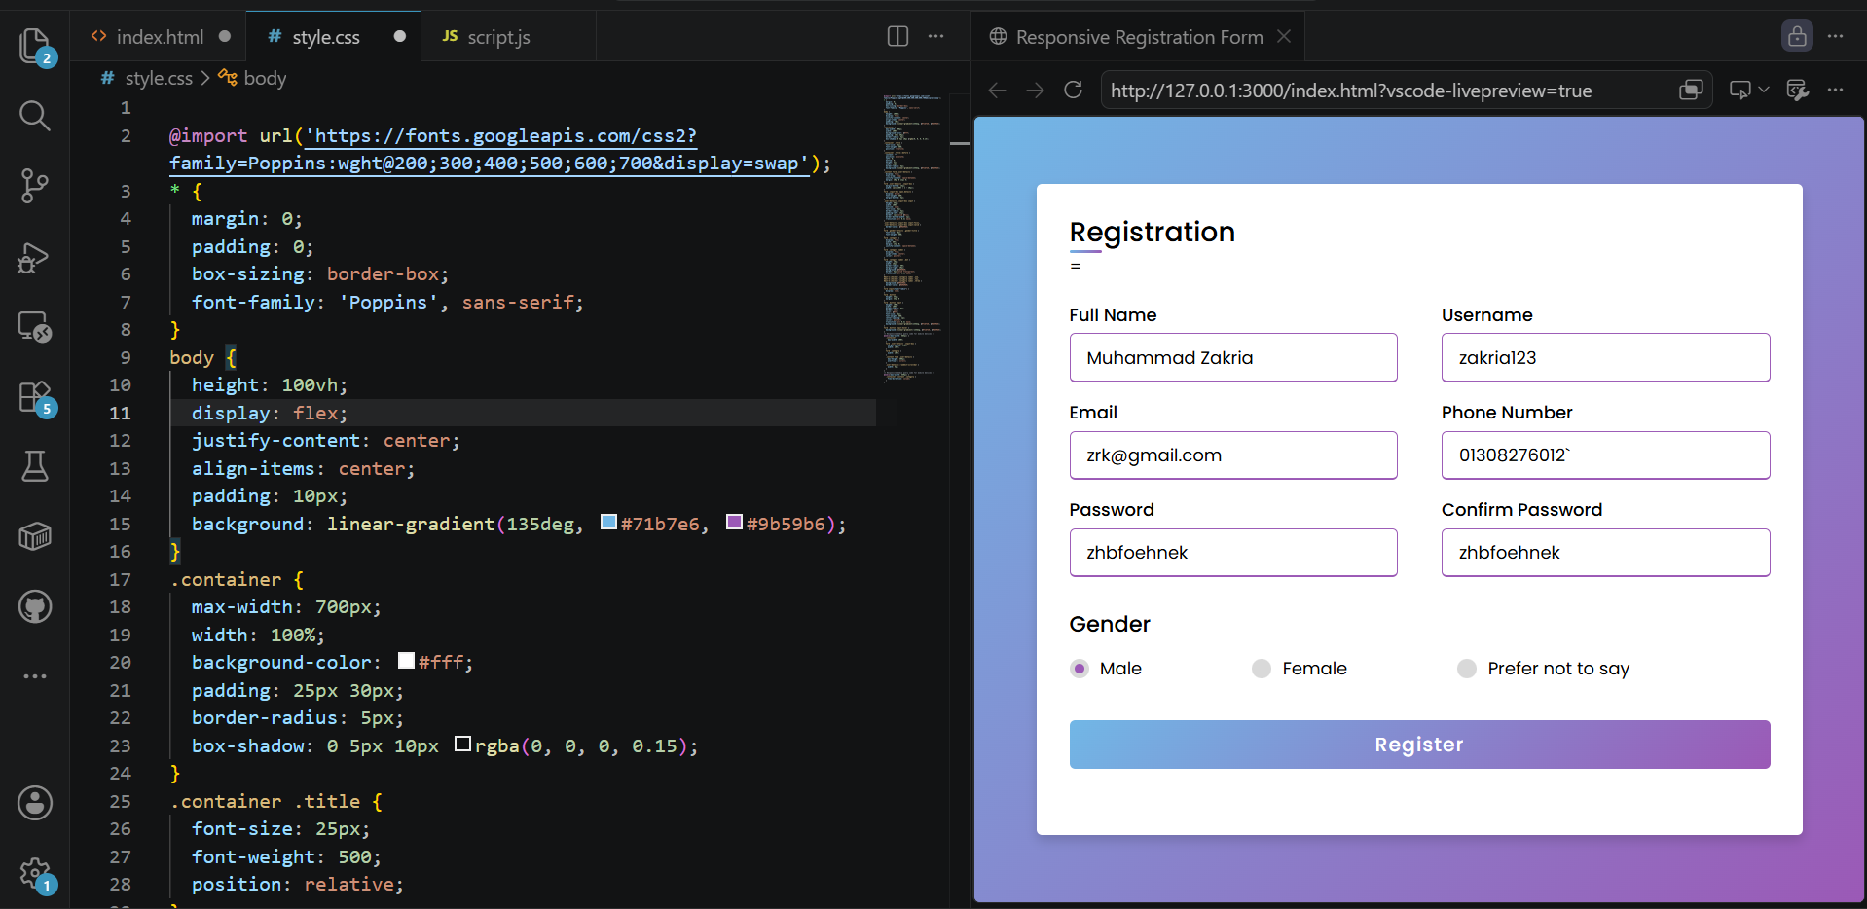

Lab Work Additional:
